Examples Of Conversion

- The 3,000 on Pentecost – Acts 2:21-47
  - Mark 16:16:
  - Immediately or Delayed?
- Samaritans – Acts 8:5-14
  - Mark 16:16:
  - Immediately or Delayed?
- Simon – Acts 8:13
  - Mark 16:16:
  - Immediately or Delayed?
- Eunuch – Acts 8:26-39
  - Mark 16:16:
  - Immediately or Delayed?
- Saul – Acts 9:1-18; 22:10-16; 26:2-21; Gal. 1:23; I Tim. 1:13
  - Mark 16:16:
  - Immediately or Delayed?
- Cornelius – Acts 10:1-48; 11:1-18
  - Mark 16:16:
  - Immediately or Delayed?
- Sergius Paulus – Acts 13:4-12
  - Mark 16:16:
  - Immediately or Delayed?

- Lydia – Acts 16:13-15
  - Mark 16:16:
  - Immediately or Delayed?
- Jailer – Acts 16:25-34
  - Mark 16:16:
  - Immediately or Delayed?
- Crispus & Corinthians – Acts 18:8; I Cor. 1:2
- Mark 16:16:
- Immediately or Delayed?
- Galatians – Gal. 3:26-27
  - Mark 16:16:
  - Immediately or Delayed?
- Ephesian Disciples – Acts 19:4-5
  - Mark 16:16:
  - Immediately or Delayed?
- Colossians – Col. 1:3-10; 2:11-12
- Mark 16:16:
- Immediately or Delayed?

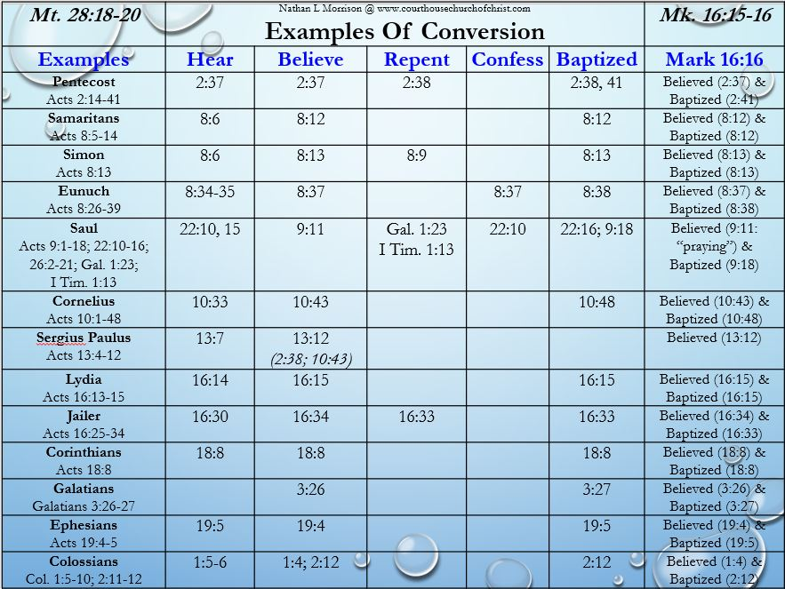

Morrison Publishing 2019

www.courthousechurchofchrist.com; 804-277-1983

Baptism Part 3: Examples Of Conversion
Prepared by Nathan L Morrison for Sunday August 4th, 2019
Text: Matthew 28:18-20; Mark 16:15-16

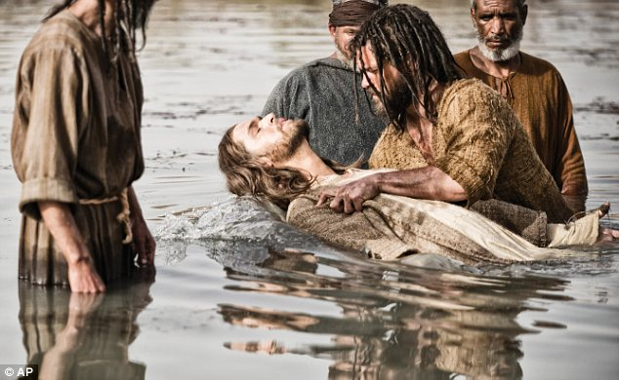

Matthew 28:18-20
18. And Jesus came up and spoke to them, saying, "All authority has been given to Me in heaven and on earth.
19. "Go therefore and make disciples of all the nations, baptizing them in the name of the Father and the Son and the Holy Spirit,
20. teaching them to observe all that I commanded you; and lo, I am with you always, even to the end of the age."

Mark 16:15-16
15. And He said to them, "Go into all the world and preach the gospel to all creation.
16. "He who has believed and has been baptized shall be saved; but he who has disbelieved shall be condemned.

