Godly Women Series 2019 Part 6

Shunammite: “It Is Well”
Prepared by Nathan L Morrison for Sunday June 9th, 2019
Text: II Kings 4:8-37

Intro
- There are examples both good and bad in the Scriptures.
- Men and women alike can provide us with sources of strength and inspiration.
  - Eve: “Mother of all living” (Gen. 3:20) and an example of moving past sin!
  - Sarah: Mother of nations (Gen. 17:16), Mother of saints (Gal. 4:26,31), Mother of godly wives (I Pet. 3:6), and is an example of faith and overcoming one’s weaknesses!
  - Ruth: An example of faith and virtue (Ruth 1:16-18; 3:11)!
  - Abigail: An example of faith, respect, wisdom, and concern! (I Sam. 25)
  - Proverbs 31 Woman: Her relationships, behavior, and character were “excellent” (“virtuous”) and she was a woman of great faith! (Prov. 31:10-31)
- Godly role models are greatly needed today!
- There is recorded for us in II Kings 4 an account of a “great woman,” who was more than just “great” because of her material possessions.
- The Shunammite woman is a great example for everyday living and how we can make a difference!
- II Kings 4:8: “Elisha passed over to Shunem, where there was a prominent woman.”
NASB: “Prominent woman” – The NASB margin in most Bibles says, “Great.”
KJV: “Great woman”
NKJV: “Notable woman”
ESV: “Wealthy woman”
  - Heb. gadol (H1419): “Great (in any sense); bigger, exceedingly, extremely, great man, great woman, greater, greatest, greatness, main, major, mighty and great, prominent, rich”
- This woman in her everyday living demonstrated hospitality, contentment, and faith!

- She Was Hospitable
- II Kings 4:8-10
  - Elisha came to Shunem – A border city in the tribe of Issachar (Josh. 19:17-18), and was about 3 miles north of Jezreel (place of Ahab’s palace and Jehu’s massacre), near Mount Gilboa.
  - Two women mentioned from Shunem: Abishag, the beautiful young maiden that attended to David in his old age (I Kings 1:3) and the unnamed woman in II Kings 4 that attended to Elisha.
- She provided Elisha food to eat
  - “She persuaded him to eat food.”
  - She provided a place for Elisha to turn in and eat and refresh himself as he traveled.
  - She recognized Elisha as a “holy man of God” and she asked her husband to build him his own room with furnishings for him to stay at when he passed by.
- She provided Elisha a place to stay when he came through
  - She did more than merely feed the prophet (4:9-10).
  - She thought of his needs and prepared a place for him to stay when he was in the area.
  - She could feed him and she could also offer a place for him to sleep and rest and so she did so.
- She showed great hospitality to the prophet
  - She knew his needs and provided for them: a table, a chair, a bed, and a candlestick (4:10)
  - Some say they would serve if they had the ability or talent.
  - This woman said, “I will do what I can.”
  - She was not a prophet (like Deborah), nor a leader of people (like Deborah & Esther).
  - But she could cook and provide for God's prophet.
  - She could show hospitality (In the Greek it lit. means “Love to strangers,” Thayer)
- Application to us today:
  - Rom. 12:6, 13: Each of us have different abilities and are to use them accordingly. We are to use what we have!
  - I Pet. 4:9; Heb. 13:2: Practicing hospitality is one of the things we can do (Elders have to be known for their hospitality – I Tim. 3:2; Titus 1:8). – In practicing hospitality, you never know who you will help!
  - Something that may seem so little to us, but can mean so much in the life of another! (Some have helped angels! – Heb. 13:2)
- She served God with the abilities she had, and is an example for us to use what we have to the best of our abilities!

She Was Content
  - II Kings 4:11-13
    - Elisha appreciated all she did for him and wanted to pay her back.
    - He asked if he could even grant her a favor from the king or the captain of the army!
    - Elisha asked the Shunammite woman, “What can I do for you?”
    - How would you respond?
  - “I live among my own people.”
    - She basically said, “I don't need anything. I am satisfied to live among my own people.”
    - She was happy with where she was in life.

Her service was not rendered for what she thought she could get out of it.

She served for the joy of it.

The result was contentment and peace.

This woman understood the source of contentment: serving God with all she had!
  - Application to us today:
    - So many people today search for happiness and joy and look in the wrong places!
    - Phil. 4:6-7: “Be anxious for nothing.” Be content and peace will follow through Christ.
    - I Tim. 6:6-8: Godliness is great gain when accompanied with contentment.
        - We need to find contentment in what we have: food & clothing

The Shunammite woman was content in her joy of serving God!

She Had Faith In God
- II Kings 4:14-17
  - While the woman did not make any request of Elisha or God, Elisha's servant told the prophet that the woman was without child.
  - Elisha called her back and told her that she would have a child in one year. She said, “Do not lie to your maidservant!” (This implies her great desire for a child)
  - She had the child as Elisha promised.
- From Joy to Grief
  - II Kings 4:18-21
- When the child had “grown” (but still a child) he “went to the field with his father.”
- In the field the child complained that his head hurt and was carried back to his mother.
- She rocked her child in her lap until noon. At noon, the boy died in his mother's arms.
- “It Will Be Well”
  - Think of how she must have felt that day!
- Bitterness could have caused her to say, “Why did God do this to me?” That type of bitterness is not found in her response.
- II Kings 4:22-23: She took the lad and laid him in the prophet's bed. She told her husband she was going to see the prophet (she knew where he would be) but didn’t tell him their son was dead.
- She told him, “It will be well.” (She didn’t wail and mourn)
- “It Is Well”
  - II Kings 4:24-30
  - She left with a servant as fast as she could go (Vs. 24) to Mount Carmel.
  - Elisha saw her coming and knew something was wrong. He sent Gehazi to ask, “Is it well?”
  - She said, “It is well” then emotionally pleaded with Elisha and told him she wouldn’t leave him.
  - II Kings 4:31-37: Elisha prays to God, his prayer is answered, and the boy is restored to life and reunited with his mother!
  - She had such faith in God that she trusted God would do what was best for her.
- Application to us today:
- Rom. 8:28: We are to have that kind of faith! (Romans 8:29-39 tells us in Jesus nothing can separate us from the love of God!) – Hymn, “It Is Well” by H.G. Spafford (1873)
- Rom. 8:18: Whatever hardships we endure in life, nothing compares to the glory of Heaven!
- Job 2:10: Job is also an example of this. When he lost everything, even his health, he said, “Shall we indeed accept good from God and not accept adversity?” It says he did not sin against God with his lips.
- Her calmness and faith in God despite great tragedy serves as example for us today, in that whatever befalls us we should say, “It is well!”

Conclusion
- Some people sit on their talents saying, “If only I had this other gift as well, I’d really do some good!” Or, “When I get or obtain this or that, I’ll do some good!”
- The Shunammite woman illustrates for us today: we can serve God with what we have!
- This unnamed woman was “great” because she served God with the abilities she had!
      - She was hospitable
      - She was content
      - She had faith in God
- We need to do likewise and serve God with the abilities we have, no matter how small we think they are!
  - Mt. 10:40-42: They that do these things shall not lose their reward.
- Whatever the trials or distress, let us have faith in God to declare, “It is well!”
- If you are not a Christian, you are not serving God but yourself. Repent and be baptized!
- If a Christian, perhaps you haven’t been serving Him to the best of your ability. Repent!
- Whatever your requests may be, come forward NOW and let them be known while we stand and sing.

It Is Well With My Soul (1873)
By Horatio G. (H.G.) Spafford (October 20, 1828 – October 16, 1888)
and Music by P. Bliss (1838 –1876)

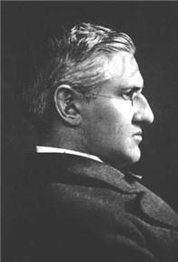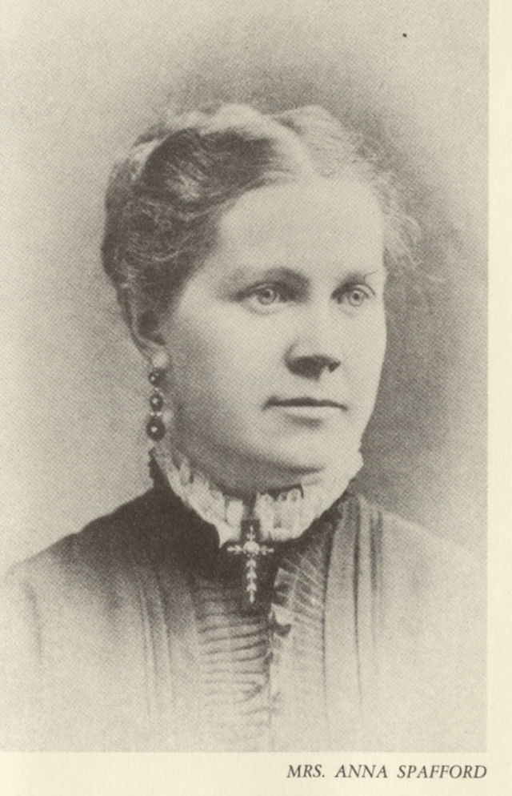
H.G. Spafford Anna Spafford

On October 8, 1871, the Great Chicago Fire swept through the city. Horatio was a prominent lawyer in Chicago, and had invested heavily in the city's real estate, and the fire destroyed almost everything he owned.
Two years later, in 1873, Spafford decided his family should take a holiday somewhere in Europe, and chose England. He was delayed because of business, so he sent his family ahead: his wife and their four children, daughters eleven year old Anna “Annie”, nine year old Margaret Lee, five year old Elizabeth “Bessie”, and two year old Tanetta.
On November 22, 1873, while crossing the Atlantic on the steamship Ville du Havre, their ship was struck by an iron sailing vessel and two hundred and twenty-six people lost their lives, including all four of Spafford's daughters. Anna Spafford, his wife, survived the tragedy. Upon arriving in England, she sent the now famous telegram to Spafford beginning with, “Saved alone.”
Spafford then sailed to England, going over the location of his daughters' deaths. According to Bertha Spafford Vester, a daughter born after the tragedy, Spafford wrote “It Is Well With My Soul” on this journey, close to or over the spot of where he lost his four daughters.
Following the sinking of the Ville du Havre, Anna gave birth to three more children. On February 11, 1880, their son, Horatio Goertner Spafford, died at the age of four, of scarlet fever. Their daughters were Bertha Hedges Spafford (born March 24, 1878) and Grace Spafford (born January 18, 1881).
Four days shy of his 60th birthday, Spafford died on October 16, 1888, of malaria, and was buried in Mount Zion Cemetery, Jerusalem.

