Harmony Of Scriptures & Science Part 1
Prepared by Nathan L Morrison for Sunday April 22nd, 2018
Text: Ps. 19:1; Is 40:8; Rom. 1:20
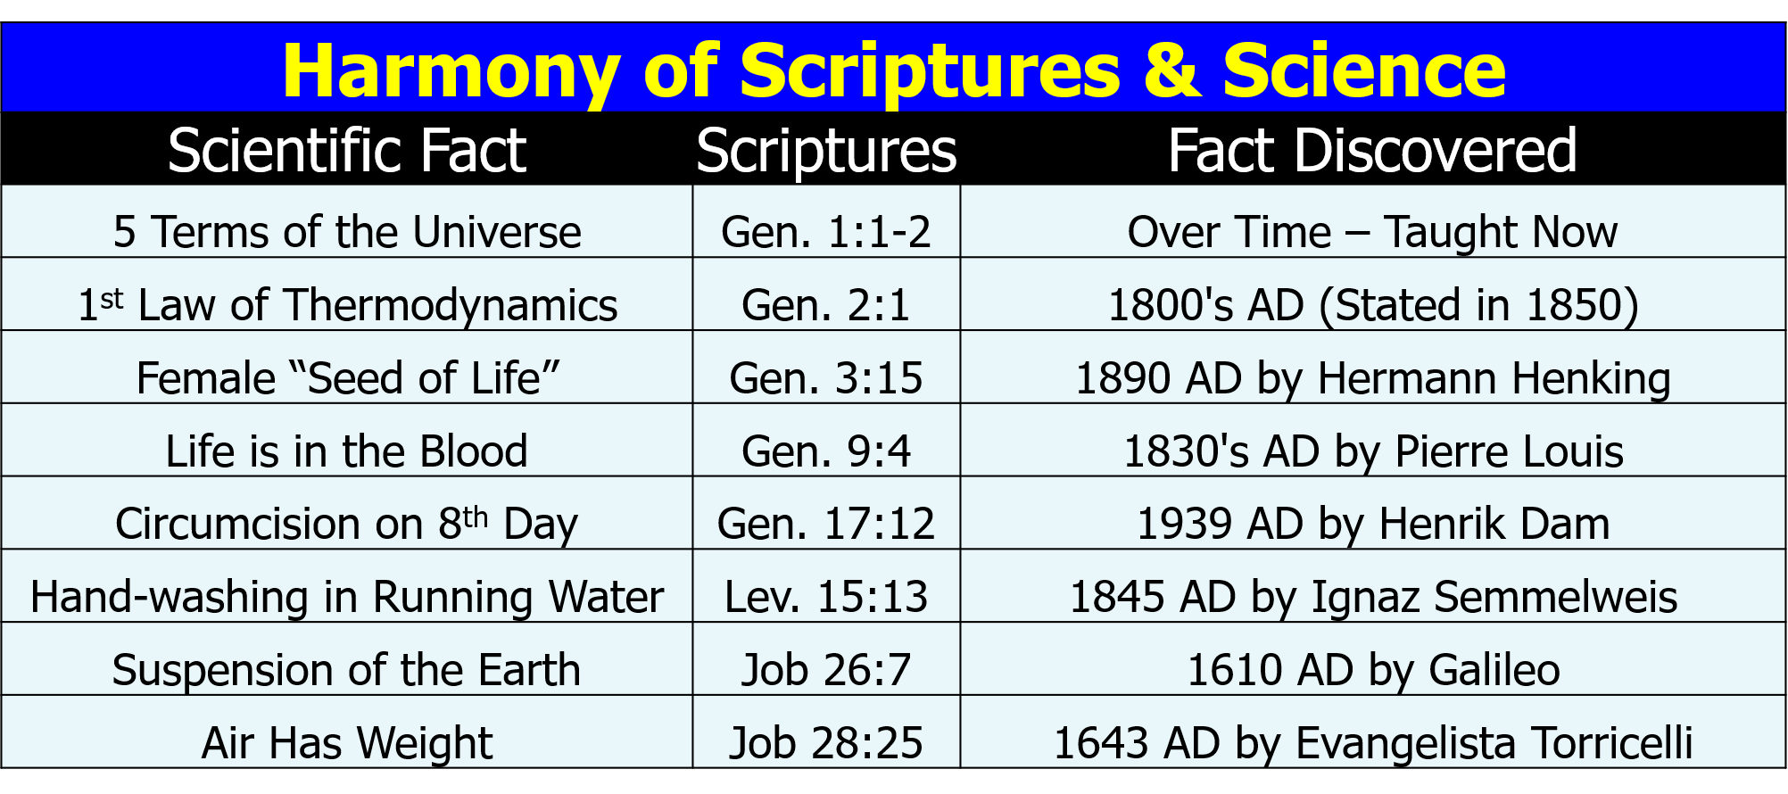
- 5 Terms of the Universe – Gen. 1:1-2
  - _________________________________
  - _________________________________
  - _________________________________
- 1st Law of Thermodynamics – Gen. 2:1
  - _________________________________
  - _________________________________
  - _________________________________
- Female “Seed of Life” – Gen. 3:15
  - _________________________________
  - _________________________________
  - _________________________________
- Life in the Blood – Gen. 9:4
  - _________________________________
  - _________________________________
  - _________________________________
- Circumcision on 8th Day – Gen. 17:12
  - _________________________________
  - _________________________________
  - _________________________________
- Hand-washing in Running Water – Lev. 15:13
  - _________________________________
  - _________________________________
  - _________________________________
- Suspension of the Earth in Space – Job 26:7
  - _________________________________
  - _________________________________
  - _________________________________
- Air Has Weight – Job 28:25
  - _________________________________
  - _________________________________
  - _________________________________

Image: Painting, “Hands of Creation,” by Evelyn Patrick
Resources:
- Science Increasingly Makes the Case for God, Wall Street Journal Article by Eric Mataxas, 12/25/14: http://www.wsj.com/articles/eric-metaxas-science-increasingly-makes-the-case-for-god-1419544568
- http://www.evidencebible.com/witnessingtool/scientificfactsintheBible
- 5 Terms of the Universe: http://www.spaceandmotion.com/cosmos-space-time-matter-motion.htm
- 1st Law of Thermodynamics: http://en.wikipedia.org/wiki/1st_law_of_thermodynamics
- Female “Seed of Life”: http://www.custance.org/Library/SOTW/Part_II/chapter15.html; http://en.wikipedia.org/wiki/Hermann_Henking
- Life is in the Blood/Bloodletting: http://en.wikipedia.org/wiki/Pierre_Charles_Alexandre_Louis; http://www.pbs.org/wnet/redgold/basics/bloodlettinghistory.html; Childbed Fever: A scientific biography of Ignaz Semmelweis, by Codell K. & Barbara R. Carter, 2005
- Circumcision on 8th Day: http://en.wikipedia.org/wiki/Vitamin_K#History_of_discovery; http://en.wikipedia.org/wiki/Carl_Peter_Henrik_Dam; None of These Diseases by S.I. McMillen, M.D., p. 93, 1984
- Hand-washing in Running Water: http://en.wikipedia.org/wiki/Ignaz_Semmelweis; http://en.wikipedia.org/wiki/Louis_Pasteur
- Suspension of the Earth: http://en.wikipedia.org/wiki/Ptolemaic_System#Ptolemaic_system; http://en.wikipedia.org/wiki/Copernican_system
- Air Has Weight: http://superbeefy.com/who-discovered-air-pressure-and-that-the-atmosphere-has-weight-and-presses-down-on-us/; https://en.wikipedia.org/wiki/Evangelista_Torricelli; http://www.kids-fun-science.com/air-pressure-experiments.html

For further study, or if questions, please Call: 804-277-1983 or Visit www.courthousechurchofcrist.com

Morrison Publishing, 2018

Harmony Of Scriptures & Science Part 1
Prepared by Nathan L Morrison for Sunday April 22nd, 2018
Text: Ps. 19:1; Is 40:8; Rom. 1:20

Image: “Pillars of Creation” in the Eagle Nebula taken by the Hubble Telescope in 2014
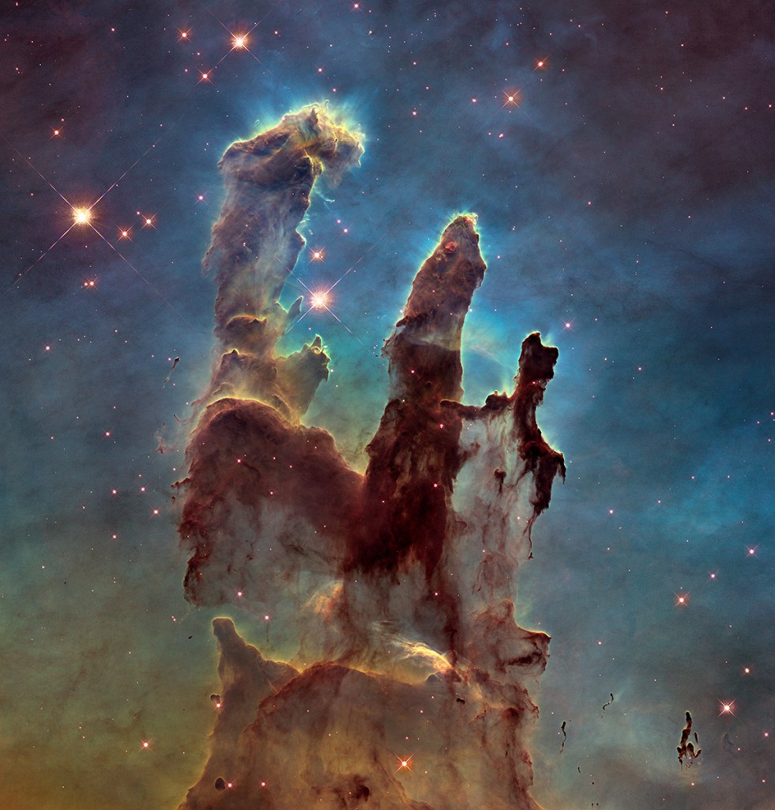

Psalms 19:1: To the Chief Musician. A Psalm of David.
“The heavens declare the glory of God; And the firmament shows His handiwork.”

Wall Street Journal article from 12/25/14, Science Increasingly Makes the Case for God by Eric Mataxas, declares that scientists are increasingly having to change their previous thoughts!

